# Scaling Risk Estimates – VaR(95%) Forecast

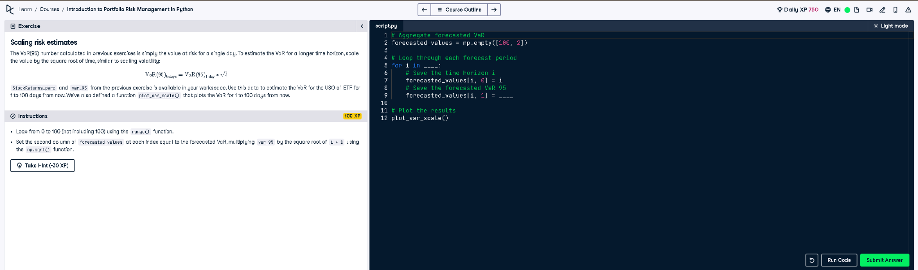

## Python Code

# Aggregate forecasted VaR  
forecasted_values = np.empty([100, 2])  
  
# Loop through each forecast period  
for i in range(100):  
 # Save the time horizon i  
 forecasted_values[i, 0] = i  
 # Save the forecasted VaR 95  
 forecasted_values[i, 1] = var_95 * np.sqrt(i + 1)  
  
# Plot the results  
plot_var_scale()

## Simple Explanation (50 Words)

This code forecasts VaR(95%) from 1 to 100 days by scaling the one-day VaR using the square root of time. It uses a loop and multiplies the single-day VaR by sqrt(i+1) to get the value at each horizon. Results are stored and plotted using plot_var_scale().